Intermediate Algebra Lecture 12.6: Studying Common and Natural Logarithms.

Common logs: A base of 10.
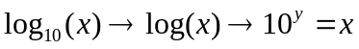

Example
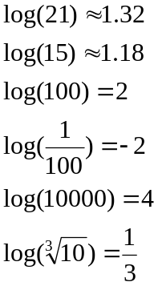

Example
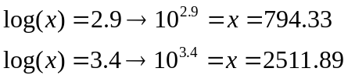

Richter scale
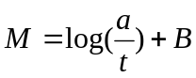
Where “a” is amplitude and “t” is time plus the correction factor

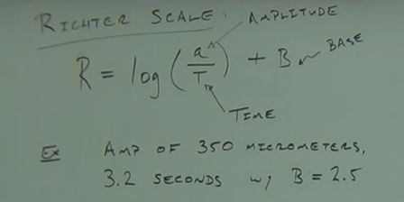

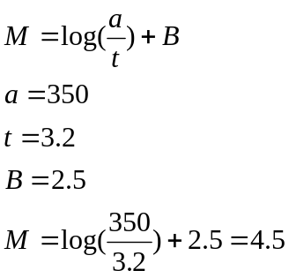

Natural log: A log with a base of e.
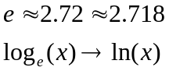

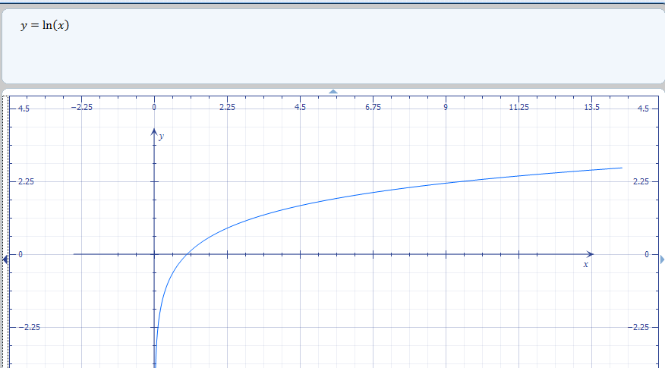

Example
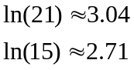

NOTE
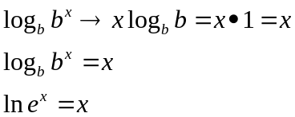

Example
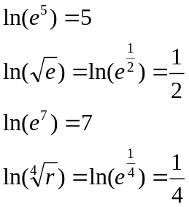

Solving
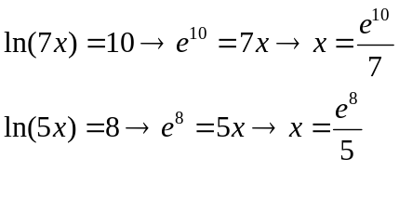
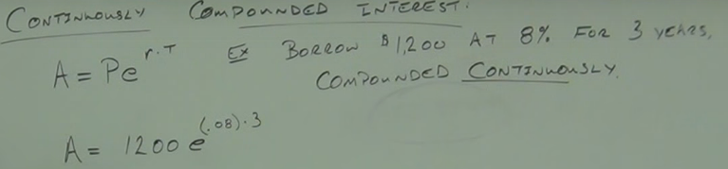
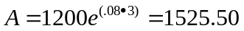

Change of Base
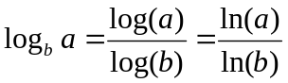
Example
